LGE VS [OEM NAME] [PROJECT NAME]

System Integration Test Plan (SysITP)

LGE Internal Use Only

About This Template
- Template Name: LGE_VS_SysIT_T01_SysITP(System Integration Test Plan)
- Management Department: VS SW Process Team
- Revision History
Version | Date | Comment | Author
2.0 | 2017-10-16 | Initial Release  - Modified from LGE_VC_Template_TMP(Test_Master Plan_v1.0 to comply with A-SPICE 3.0 and ISO 29119 | VC Smart SW Process Team  LG Electroincis
2.1 | 2019-03-08 | Update due to annual organization restructuring (VC --> VS) | VS Smart SW Process Team
2.3 | 2021-08-27 | (* actually updated in ’19.11.13 by Ilsun Jang)  Updated ‘1. Plan Context’, ‘3.6 Test Design Techniques’, ‘3.7 Test Entry/Completion Criteria’, ‘3.8 Metrics to be collected’, ‘3.11 Test Environment Requirements’. | VS Smart SW Process Unit
2.3 | 2021-08-27 | Updated security notice of this template (Before: LGE Confidential->After: LGE Internal Use Only).  Security level related note (the last sentence in red color below) | VS Smart SW Process Unit
2.4 | 2022-04-04 | Create Ch.3 System Integration Strategy to supplement guidelines, examples, and review procedures | VS Smart SW Process Unit
2.5 | 2022-12-12 | Change the responsibility for establishing a system integration strategy in the chapter 3. System Integration Strategy and supplement guidelines, and examples | VS Smart SW Process Unit

Read me first
- This template is the default form for “SysITP (System Integration Test Plan)“ document, which consists of the writing guidelines(green box) and examples.
- Before writing this document, read and keep in mind the contents of “General Guidelines”.
- Once you have finished to write a document, delete all writing guidelines(green box).
- The contents of this template may not be 100% correct for all projects, so writers should use it after tailoring the contents to the project size and characteristics.
- In test domain, the term “Item” is used.
So, the term “Element” and “Component” should not be used.
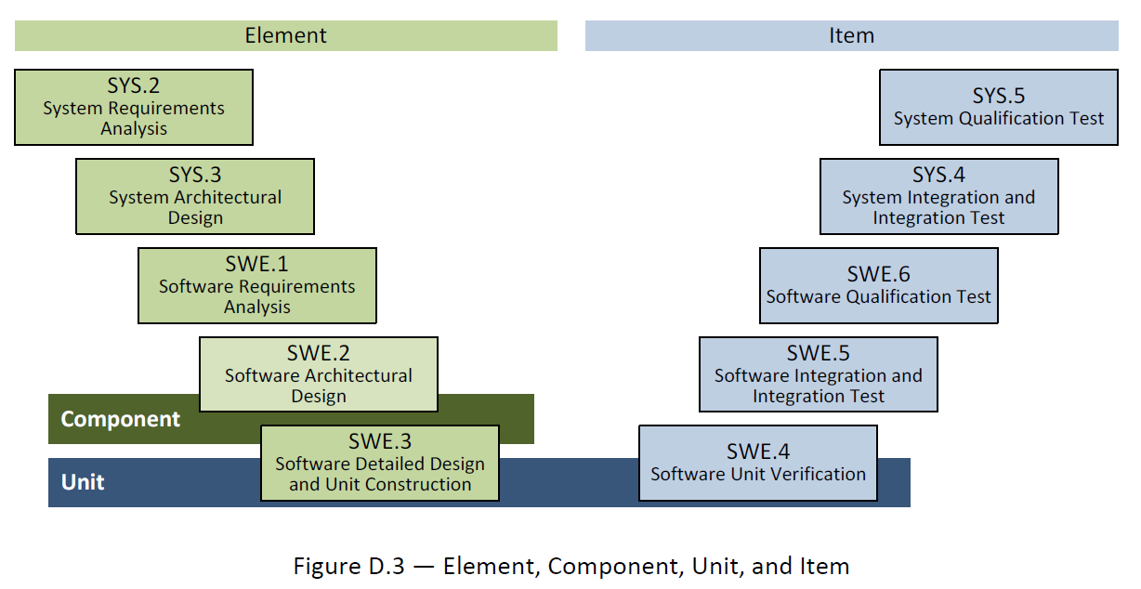
- The notice “LGE Internal Use Only” is for this template itself. The document which use this template needs to be classified as suitable security level according to its content.

General Guidelines
- Ground Rules for SysITP
- The system integration test plan for each test area is to verify each development area. The test target and criteria of the test area are planned based on the corresponding development area.
- Depending on the project situation, SysITP should be tailored under consultation with relevant stakeholders.
- Seven Rules
- Write in the reader's perspective.
- Avoid unnecessary repetition of information in the document.
- Make sure there is no ambiguity in the document. Explicitly specify the meaning of the notations used in the diagram.
- Use the standard structure of the document. Make a structure that is easy to refer to. Mark areas that are difficult to define as "to be determined" instead of leaving them blank.
- Record the rationals for adopting the specific test. This is useful for future review or modification.
- Do not immediately reflect changes in the document. Instead, reflect them by the document's version control and release schedule.
- Ask audiences for a review.
- References
This template has been revised by referring to the following test related technical data and the TMP template and guidance document which have been distributed in the past.
- Automotive_SPICE_PAM_v3.0
- ISO/IEC/IEEE 29119 Software Testing Standard
- ISO/IEC/IEEE 25010:2011 Systems and Software Engineering
- Previously deployed TMP templates and guidelines of VS Smart Division
- Document Format
If you use this template, you do not have to worry about document format. The following basic rules should be observed.
- Give numbers and titles to all pictures and tables and make them easy to be refered.
- Caption Add : [Menu of MS Word] > [Reference] > [Add Caption] > [Lable] > Select “Figure” or “Table” and click “OK” button
- Caption Location
Insert caption below “Picture” : Figure 1 Picture Title, Figure 2 Picture Title, …
Insert caption above “Table” : Table 1 Table Title, Table 2 Table Title, …
- Document Versioning, File Naming Rule
See "Naming Conventions for Work Products" in the Configuration Management Guidelines (LGE_VS_Guideline_ Configuration Management) maintained within the project.

About This Document
Document Information
Issuing authority | VS OOO Team
Configuration ID | Configuration Item ID of CMBook
Status of document | In Progress / Approved / Released
Revision History
Write the Revision History. Make sure the latest content is at the top.

Verion | Date | Comment | Author | Approver
#.# | YYYY-MM-DD | OOOOOOO | OOO | OOO
Purpose
Write about the purpose of this document.
This document is the System Integration Test plan of the [project name] project.
Scope
Write the scope of this document.
This document contains the following:
- Strategy, Scope, Quality Goal, Role and Responsibility, Methodology, Schedule, Deliverables, Measurement, Regression Test, Criteria, Environment, Constraint, Risk
Audience
Write the audience for this document.
The audiences of this document are as below:
- Project Manager, Project Leader, Project Sub-leader, SW Engineer, HW Engineer, Test Engineer, Configuration Manager, Requirement Manager
Related Documents
Write documents related to the use of this document.
The related documents of this document are as below:
- LGE_[OEM]_[Project Name]_TMP
- LGE_[OEM]_[Project Name]_SWUTP
- LGE_[OEM]_[Project Name]_SWITP
- LGE_[OEM]_[Project Name]_SWTP
- LGE_[OEM]_[Project Name]_SysITP
- LGE_[OEM]_[Project Name]_SysTP
- LGE_[OEM]_[Project Name]_SWUTC
- LGE_[OEM]_[Project Name]_SWITC
- LGE_[OEM]_[Project Name]_SWTC
- LGE_[OEM]_[Project Name]_SysITC
- LGE_[OEM]_[Project Name]_SysTC
- LGE_[OEM]_[Project Name]_PMP
- LGE_[OEM]_[Project Name]_CMP
- LGE_[OEM]_[Project Name]_CMBook
- LGE_[OEM]_[Project Name]_WBS
- LGE_[OEM]_[Project Name]_PRM

Conventions and Acronyms
Conventions
Indicate the helpful and important information as below:

NOTE
Helpful Notes

CAUTION
Important Information

Acronyms
Acronym | Description
TMP | Test Master Plan
SysTP | System Qualification Test Plan
SysT | System Qualification Test
SysITP | System Integration Test Plan
SysIT | System Integration Test
SWTP | Software Qualification Test Plan
SWT | Software Qualification Test
SWITP | Software Integration Test Plan
SWIT | Software Integration Test
SWUTP | Software Unit VerficiationPlan

Table of Contents
1 Plan Context 1-1
1.1 Test Item 1-1
1.2 Test Scope 1-1
2 Risk Register 2-2
2.1 Project Risks 2-2
2.2 Product Risks 2-2
3 System Integraton Strategy 3-4
3.1 Integration Strategy 3-4
4 Test Strategy 4-8
4.1 Integration Test Strategy 4-9
4.2 Test Process 4-9
4.3 Test Deliverables 4-9
4.3.1 Test Cases 4-9
4.3.2 Test Results Report 4-10
4.3.3 Test Plan 4-10
4.4 Reviews 4-10
4.4.1 Testability Review 4-10
4.4.2 Test Case Conformity Review 4-11
4.5 Test Design Techniques 4-11
4.5.1 Specification Based Testing 4-11
4.5.2 Experience Based Testing 4-12
4.6 Test Entry/Completion Criteria 4-12
4.6.1 Entry Criteria 4-12
4.6.2 Suspension and Resumption Criteria 4-12
4.6.3 Completion Criteria 4-13
4.7 Metrics to be collected 4-13
4.7.1 The Metrics of Measurement Analsysis 4-13
4.7.2 The Metrics of Test Cases Develoment Plan 4-14
4.8 Retesting and Regression Testing 4-14
4.9 Test Data 4-14
4.10 Test Environment Requirements 4-15
4.10.1 Test Environment Overview 4-15
4.10.2 Test Tools 4-15
5 Schedule 5-16

Figures
Figure 3-1. Bidirectional Traceability and Consistency of A-SPICE PAM 3.0 4-8
Figure 3-2. Test Process 4-9
Figure 3-3. Requirements Testability Review 4-11
Figure 3-4 Metric of measurement analysis 4-13
Figure 3-5 Metric of test cases development plan 4-14
Figure 3-6. Test environment of system integration test 4-15
Figure 4-1. Workflow 5-16

Tables
Table 2-1 Project Risks 2-2
Table 2-2 Product Risks 2-3
Table 3-1 Test Techniques of Specification Based Testing 4-12
Table 3-2 Test Techniques of Experience Based Testing 4-12
Table 3-3 Entry Criteria 4-12
Table 3-4 Suspension/Resumption criteria 4-13
Table 3-5 Completion Criteria 4-13
Table 3-6 Quality objective plan 4-14
Table 3-7 Test cases develoment plan 4-14
Table 3-8 Test Data 4-14
Table 3-9 Test tools of system integration test 4-15

Plan Context

Test Item
Describe an overview of the System Integration Test Item.
Visualize it by inserting related Collab Link.

Test Scope
The system integration area developed by LGE should be defined and explained as Test Scope.

Risk Register
The risk related with the test should be identified from the predefined risk in the project.
If there is no predefined risk, do not write it as optional.

Project Risks
※ Risk = Likelihood × Impact
※ Likelihood : 1(Low), 2(Medium), 3(High) / Impact : 1(Low), 2(Medium), 3(High)
ID | Project Risk | Likelihood | Impact | Risk Score | Mitigation Activities
P1 | Lack of testing skills
P2 | Lack of human resources
P3 | Training issue
P4 | Low quality design
P5 | Delivery delay of Chipset, etc.
P6 | Lack of human resources (Supplier)
P7 | Not enough test schedule
P8 | Delay of establishing test environ.
P9 | Dalay of developing test data
P10 | …

Table 2-1 Project Risks

Product Risks
※ Risk = Likelihood × Impact
※ Likelihood : 1(Low), 2(Medium), 3(High) / Impact : 1(Low), 2(Medium), 3(High)
ID | Project Risk | Likelihood | Impact | Risk Score | Mitigation Activities
R1 | AAA (Complex Functionality)
R2 | BBB (Func. developed newly)
R3 | CCC (Func. w/ big code size)
R4 | DDD (Func. w/ high tech. difficulty)
R5 | EEE (Applying new technology)
R6 | FFF (Lack of development experience)
R7 | GGG (Func. w/ high ext. visibility)
R8 | HHH (Func. w/ sensitive safety issue)
R9 | III (Func. w/ high intensity – Light/Sound)
R10 | JJJ (Func. w/ high impact on reputation)
R11 | …

Table 2-2 Product Risks

System Integraton Strategy

Integration Strategy
The PL or SW PL is responsible for establishing/integrating the system integration strategy, and discusses the following with the system architect (or system engineer) system integration test manager to create the system integration strategy..
- Systems integration strategy should have an integration sequence. (It must be aligned with the project plan schedule/release schedule.)
- Integration targets must be identified. (Based on System Items identified in System Architectural design)
- A product HW, device, and SW integration strategy must be established. If the integration level is divided into several levels, the detailed integration strategy for each level and the person in charge of implementation must be specified in the integration strategy.
- In the detailed system integration strategy, describe who, where, how, and under what entry and exit conditions HW, organization, and SW will proceed. Based on this, the system integration test team should be able to perform tests.
- The system integration strategy should identify system items based on the system architecture design and describe the integration sequence.
- Each system item is integrated into a complete system according to the integration strategy.

※ When creating a system integration strategy, it is necessary to create it by referring to the examples of other projects below.

ex 1) VW Telematics project
ex 1) Changes are required for the parts in red text below.
- In the phase 1 part HW+ME integration, the systems displayed in the order of steps at the bottom need to be divided into groups of sub systems defined in the System Architecture design document for each project, and the order of integration must be updated.
- Since HW+ME is integrated, you need to add Sanity Test results from the HW perspective that can check the HW integration. (Add the HW test result of simple verification after assembling or producing the board in a set state)

Integration Strategy

In the AAAA project, System integration is based on the System Architectural Design derived from the system requirements. The system elements specified in SysAD (System Architectural Design) are integrated with the interfaces between system elements according to the following strategy.

Integration phase 1: (HW + ME)
Integration Phase I in the development stage is supervised by R&D and proceeds in the pilot line.
Only development samples are mounted debug connector to use debug interfaces (UART and USB). At the mass production, debug connector will not be added in production HW. It can prevent unexpected SMT defects.
All debug interfaces (UART, USB, and Ethernet) are disabled in production SW (0-SW) and only VW can re-enable logging by using SFD. Please refer to the table in detail.

Interface | 0-HW | 0-SW | 0-SW (Log Enable by VW)
UART | Removed connector | Disabled | Not possible
USB | Removed connector | Disabled | VW can re-enable it by using SFD as defined in adaptation specification
Ethernet | Main Connector | Disabled | VW can re-enable it by using SFD as defined in adaptation specification
Table 7-3 Interfaces

R&D Samples are integrated by Manufacturing Engineering Team member.
All samples are assembled according to the working guide.

The elements of the system in the form of hardware are integrated with mechanical part.
  - The step of assembling the top cover on the main PCB.
  - The step of assembling the main PCB in the bottom cover.
  - The step of screwing the assembled parts.

The test is performed after mechanical parts are assembled.
  - Step 1. Connect CAN and Ethernet
  - Step 2. Test RF of BTLE and C2X
  - Step 3. Test DTC of antenna
  - Step 4. Test current consumption.

After test from step 1 to 4, test passed samples can be applied to the next phase.
The test results and criteria are defined in AAAA_HW_Sanity Test_[version] document.

Integration phase 2: (HW + ME + SW)
SW for integration test is downloaded by Manufacturing Engineering Team member
  - Step 1. Build manager releases SW to be integrated
  - Step 2. SWUT, SWIT, SWT are done before integration
  - Step 3. SW images are flashed on AP, MCU, and BTLE
  - Step 4. If system is up and running, system integration is completed

ex 2) VW AVN project

Integration Strategy

In the AAAA project, System integration is based on the System Architectural Design derived from the system requirements. The system elements specified in SysAD (System Architectural Design) are integrated with the interfaces between system elements according to the following strategy.

The strategy has 2 phases :

Integration phase 1 (HW + ME) :
Integration phase 1 is to target to integrate hardware and mechanic parts.
when entry criteria are ready, HW project leader and Mechanical leader should have the phase in the laboratory.

Entry criteria -
all BOMs are defined in terms of hardware and mechanical parts.

Exit criteria -
all components of them are ready on engineering side and when they are assembled without any gaps according to design, the phase is passed.

Integration phase 2 (HW + ME + SW) :
Integration phase 2 is to target to integrate all components with software.
When the system has multiple software to be implemented, all of component with software should be passed the exit criteria.
When entry criteria are ready, all stakeholders should join the phase in a certain place(cf. test lab).
Stakeholders are project leader, hardware/software/mechanic project leader, system architect, IT manager.

Entry criteria -
Integration phase 1 must be completed (it must pass exit criteria of it).
all lines on circuit must be checked(connected) in hardware. (cg. tool tester)
basic software which will make boot hardware up must be ready.
the software must be a low level software which is planned to be ported at least.
way of downloading SW should be existed.

Exit criteria -
The hardware component which has SW must start up after downloading the software.
It can be confirmed on comparing current(voltage) level between off and on.

ex 3) BMW Telematics Project
ex 3) Changes are required for the parts in red text below. Systems displayed in the order of Steps must be divided into groups of sub systems defined in the System Architecture design document for each project, and the order of integration must be updated.

Integration Strategy

In the AAAA project, System integration is based on the System Architectural Design derived from the system requirements. The system elements specified in SysAD (System Architectural Design) are integrated with the interfaces between system elements according to the following strategy.

Phase 1:
The elements of the system in the form of hardware are integrated on HW board and mechanical parts in HW production time.

Phase 2:
SW is loaded in an integrated product. The integration between the SW elements and the HW elements is performed as following steps.

- Step 1. Bring up WUC and Peripheral devices (Memory, CAN, AirBag, BTN, PWR, BUB).
- Step 2. Bring up BAM and Peripheral interface (Memory, GNSS, Ethernet, WIFI/BT).
- Step 3. Integrate System between WUC and BAM.
- Step 4. Bring up NAD and Peripheral devices (Memory, V2X, RF, SIM, Audio).
- Step 5. Integrate System between WUC and NAD.
- Step 6. Integrate System between BAM and NAD.

Test Strategy
Write about system integration test strategy.

A-SPICE PAM 3.0 document says that each development level requires each testing.
- System Qualification Testing for System Requirements
- System Integration Testing for System Architecture
- Software Qualification Testing for Software Requirements
- Software Integration Testing for Software Architecture
- Software Unit Verification for Software Detailed Design

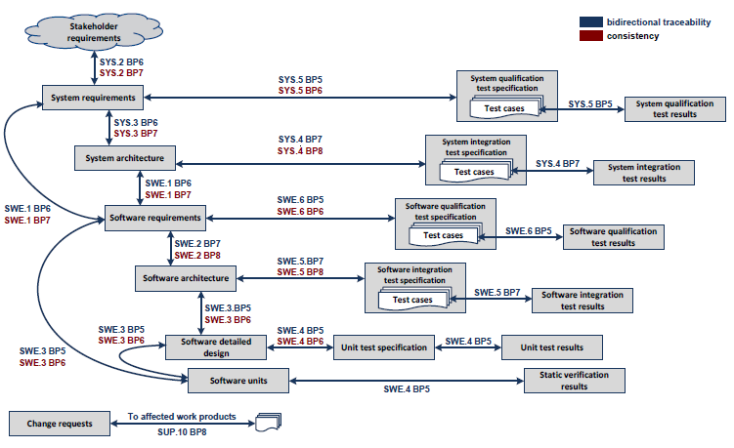
Figure 3-1. Bidirectional Traceability and Consistency of A-SPICE PAM 3.0

This project comply with A-SPICE test levels above.

The development schedule is composed of 9 releases, even though the goal is Release 7.
The duration of each iteration (release) would be as short as 3 months. Thus, Software Unit Verification should start and end at the same period of implementing. The basic testing of Software Integration is also done like SWUT. Then, 4 weeks are for testing the more specific Software Integration, Software Qualification, System Integration, and System Qualification, and 1 week for summarizing and reporting the test results.

Integration Test Strategy
Write about system integration test strategy.

Test Process
Write about system integration test procedure.

The figure below depicts the testing overview of how to test.

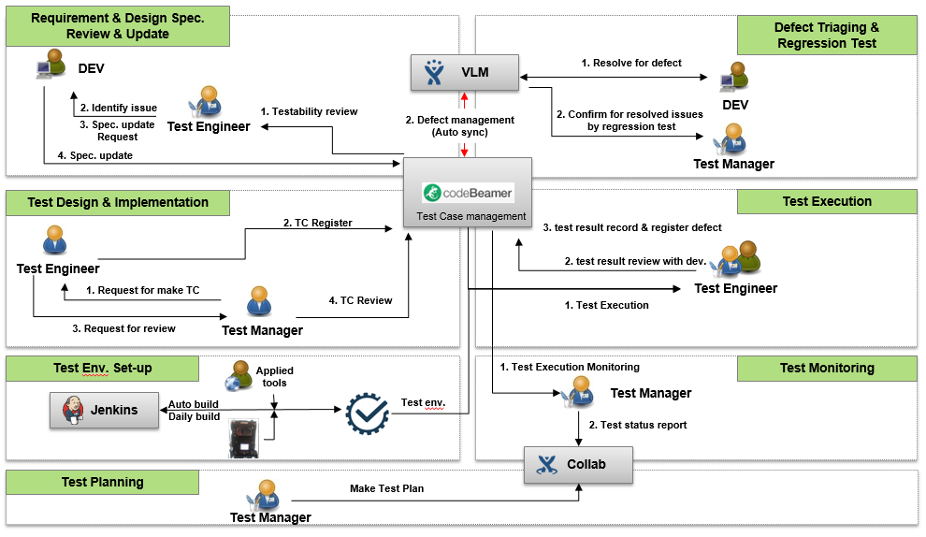
Figure 3-2. Test Process

Test Deliverables

Test Cases
Write the repository of system integration test case.
http://val.lge.com/ivi/svn/DAI_MPC5_5/trunk/03_SW_Engineering/04_Test/05_System_Integration_Test/02_System_Integration_Test_Case

Test Results Report
Write the repository of system integration test result report.
http://val.lge.com/ivi/svn/DAI_MPC5_5/trunk/03_SW_Engineering/04_Test/05_System_Integration_Test/03_System_Integration_Test_Report

Test Plan
Write the repository of system integration test plan.
http://val.lge.com/ivi/svn/DAI_MPC5_5/trunk/03_SW_Engineering/04_Test/05_System_Integration_Test/01_System_Integration_Test_Plan

Reviews

Testability Review
Write the necessary processes, tools, and checklists for the Testability Review.
Write Review Techniques (Inspection, Walkthrough, Technical Review. Etc.) to be applied for engineering document review.
The figure below depicts the overview of revewing requirements testability.
Test Manager and tets engineers review the draft documents written by the development teams with the checklists.

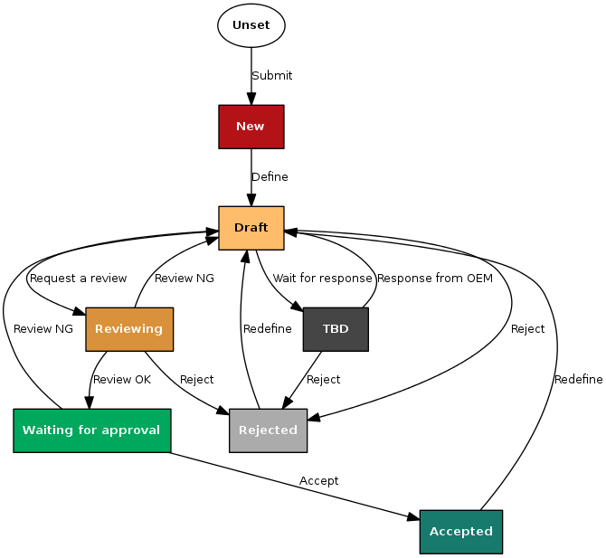
Figure 3-3. Requirements Testability Review

Test Case Conformity Review
Write the necessary processes, tools, and checklists for the Test Case Conformity Review.
Write Review Techniques (Peer Review. Etc.) to be applied for Test Case Conformity Review.

Test Design Techniques

Specification Based Testing
Write about specification based test techniques.

Test Technique | Applicable (Y or N) | Remarks
Equivalence Partitioning
Boundary Value Analysis
State Transition Testing
Test Techniques of Specification-Based Testing

Test Technique | Applicable (Y or N) | Remarks
Equivalence Partitioning
Boundary Value Analysis
State Transition Testing
Table 3-4 Test Techniques of Specification Based Testing

Experience Based Testing
Write about experience based test techniques.

Test Technique | Applicable (Y or N) | Remarks
Error guessing
Test Techniques of Experience-Based Testing

Test Technique | Applicable (Y or N) | Remarks
Error guessing
Table 3-5 Test Techniques of Experience Based Testing

Test Entry/Completion Criteria

Entry Criteria
Write about system integration test entry criteria.

Step | Criteria | Remark
Entry | When a new HW version came out or SW version release aligned with WBS.  When the test readiness checklist is identified.  The test request should be requested to the JIRA system. | QE Test Request JIRA  (http://vlm.lge.com/issue/browse/IVIQETR)
Table 3-6 Entry Criteria

Suspension and Resumption Criteria
System 통합 시험의 중단 및 재시작 조건에 대해 작성한다

Step | Criteria | Remark
Suspension | A critical issue occurred (for example. When SW binary updated but Test target does not reboot successfully. Accordingly Test cannot be started)
Resumption | A critical issue should be addressed.
Table 3-7 Suspension/Resumption criteria

Completion Criteria
Write about system integration test completion criteria.

SW Process | Criteria | Remarks
SW FC | Test case coverage for System Interface  System interface Coverage = 100% | Selected items for System Integration test scope.
SW FC | Test pass rate for SysIT  Pass Rate >= 90%
SW FC | Issue improvement rate >= 90% | No remained critical/major issue.  (No. of closed issue/No. of found issue)
SW Approval | Test case coverage for System Interface  System interface Coverage = 100% | Selected items for System Integration test scope.
SW Approval | Test pass rate for SysIT  Pass Rate = 100%
SW Approval | Issue improvement rate = 100% | Remaining defect count : 0

Table 3-8 Completion Criteria

Metrics to be collected
See the Measurement Analysis Report in more detail (http://val.lge.com/ivi/svn/DAI_MPC5_5/trunk/02_Management/10_Quality_Measurement).

The Metrics of Measurement Analsysis
Write about metrics for system integration test.

The metrics of measurement analysis is shown as below

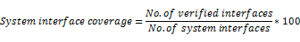

Figure 3-4 Metric of measurement analysis

Quality Objective of System Integration Test
SW Version | R1 | R2 | R3 | R4 | R5~ | Remark
System Interface Coverage | 10% | 50% | 80% | 90% | 100%
Test Case Pass Rate | 50% | 60% | 70% | 80% | 100%
Table 3-9 Quality objective plan

The Metrics of Test Cases Develoment Plan
Write about metrics for development plan of system integration test cases.

The metrics of measurement analysis is shown as below

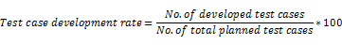
Figure 3-5 Metric of test cases development plan

The target of test cases development plan is shown as below.
Test Cases Development Plan
SW Version | R1 | R2 | R3 | R4 | R5~ | Remark
Test case development rate | 10% | 30% | 50% | 90% | 100%
Table 3-10 Test cases develoment plan

Retesting and Regression Testing
Write about the regression testing cycle(e.g. perform the regression test after retesting 3 times) and the retesting cycle.

Test Data
Write about system integration test date.

Test Data | Description
Test data for data flow | used for each sequence diagram is separately defined
Input/Output data of Componet v | Input Data  Output Data
Table 3-11 Test Data

Test Environment Requirements

Test Environment Overview
System 통합 시험 환경에 대해 작성한다

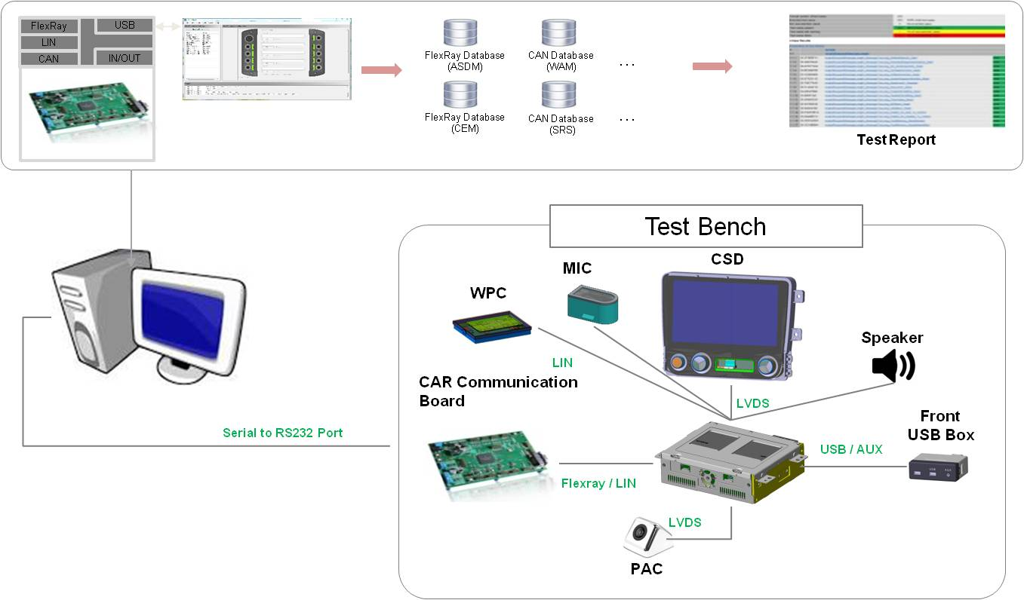
Figure 3-6. Test environment of system integration test

Test Tools
Write about system integration test tools.

Item | Description | Remark
Host PC | - Laptop  - Window 7
CANoe | - CAN/LIN Simulator  - Product: CANoe (Vector)  - Version : 10.0
MSO3054T | - Oscilloscope
Fluke 97V | - Multimeter
Table 3-12 Test tools of system integration test

Schedule
Write about system integration test schedule.
If the schedule has already been defined on the Feature Release Plan or WBS in detail, refer to the relevant documents.

Schedule for each activity can be changed flexibly according to progress status. Refer to the WBS for detailed information for each changed schedule or activity. WBS can be found on the SVN link as below:

http://val.lge.com/ivi/svn/DAI_MPC5_5/trunk/02_ProjectManagement/03_WBS/LGE_DAI_MPC5.5_WBS_v1.0.mpp

The workflow of the process is as below:

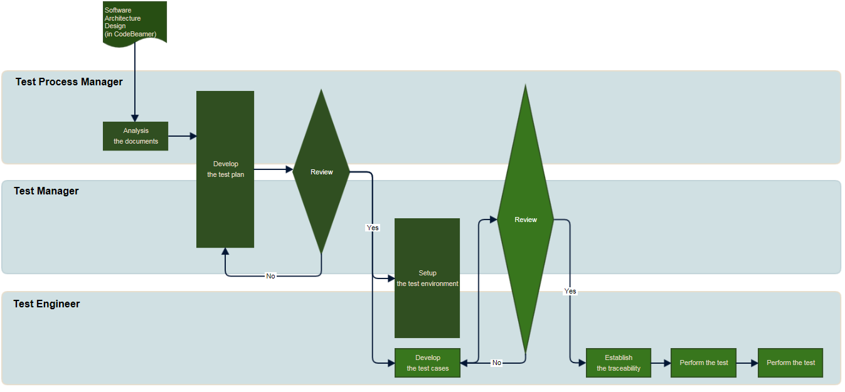
Figure 4-7. Workflow

Details can be found at the following URL.
http://collab.lge.com/main/display/DAIMPC/SWE.5+Workflow

SW Release Plan can be found at the following URL.
http://val.lge.com/ivi/svn/DAI_MPC5_5/trunk/02_Project Management/00_Guide&milestone/02_Project Milestone/LGE_DAI_MPC5.5_SW_Release_Build_Plan_All_v1.0a.xlsx

